WEEK 1 – POWER BI

- Power BI Desktop was opened to begin the process of importing, cleaning, transforming, and preparing the Superstore Sales dataset for analysis.
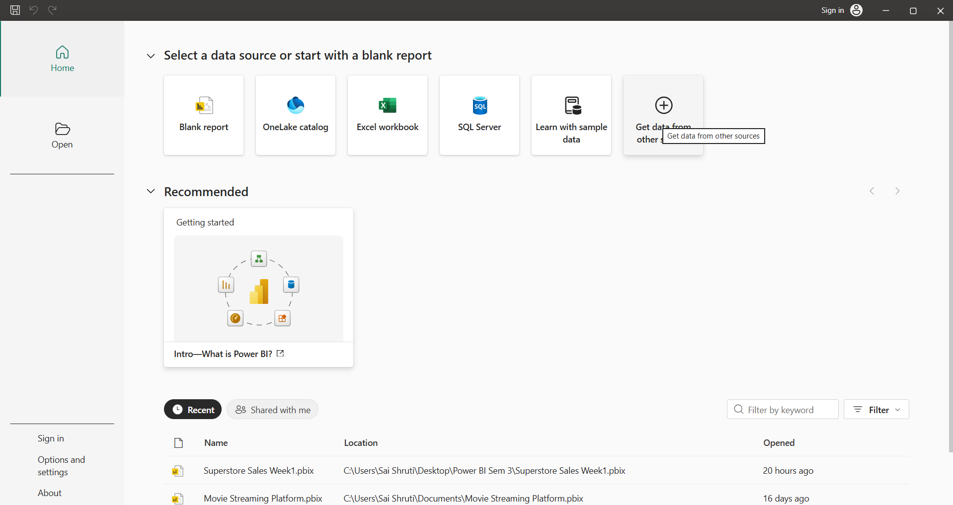
Power BI Desktop home screen used to begin the data import and preparation process

- The Superstore Sales dataset was imported into Power BI using the Text/CSV data source option. The required CSV file was selected from the system.
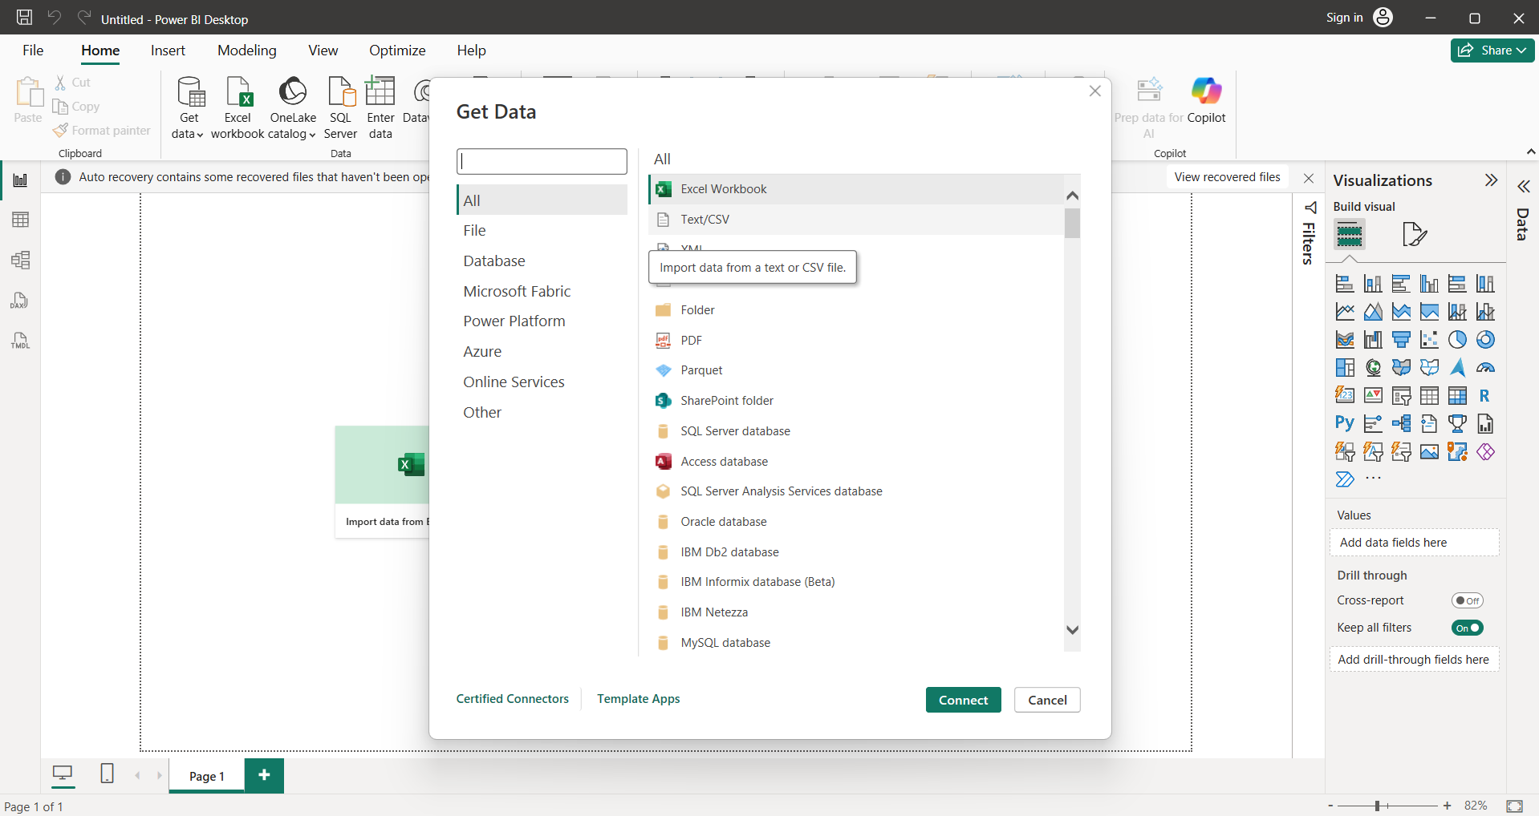
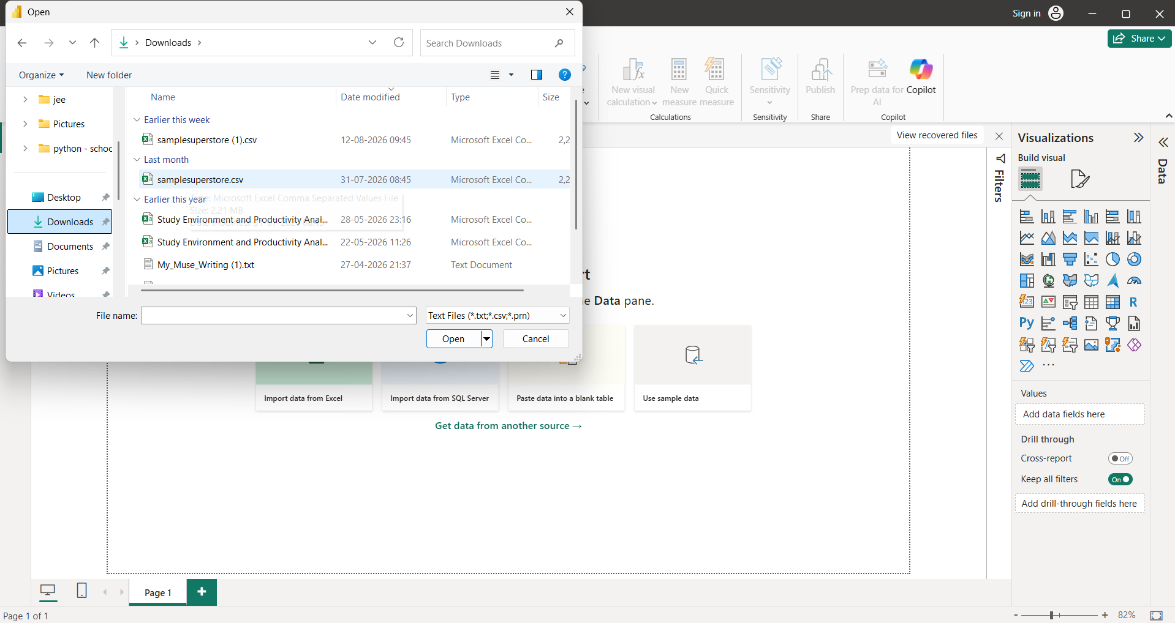
Selecting the Superstore Sales CSV file for import into Power BI

- Before loading the dataset, the CSV contents were previewed to verify the available columns and records. The dataset contains sales, customer, product, geographical, and profitability information.
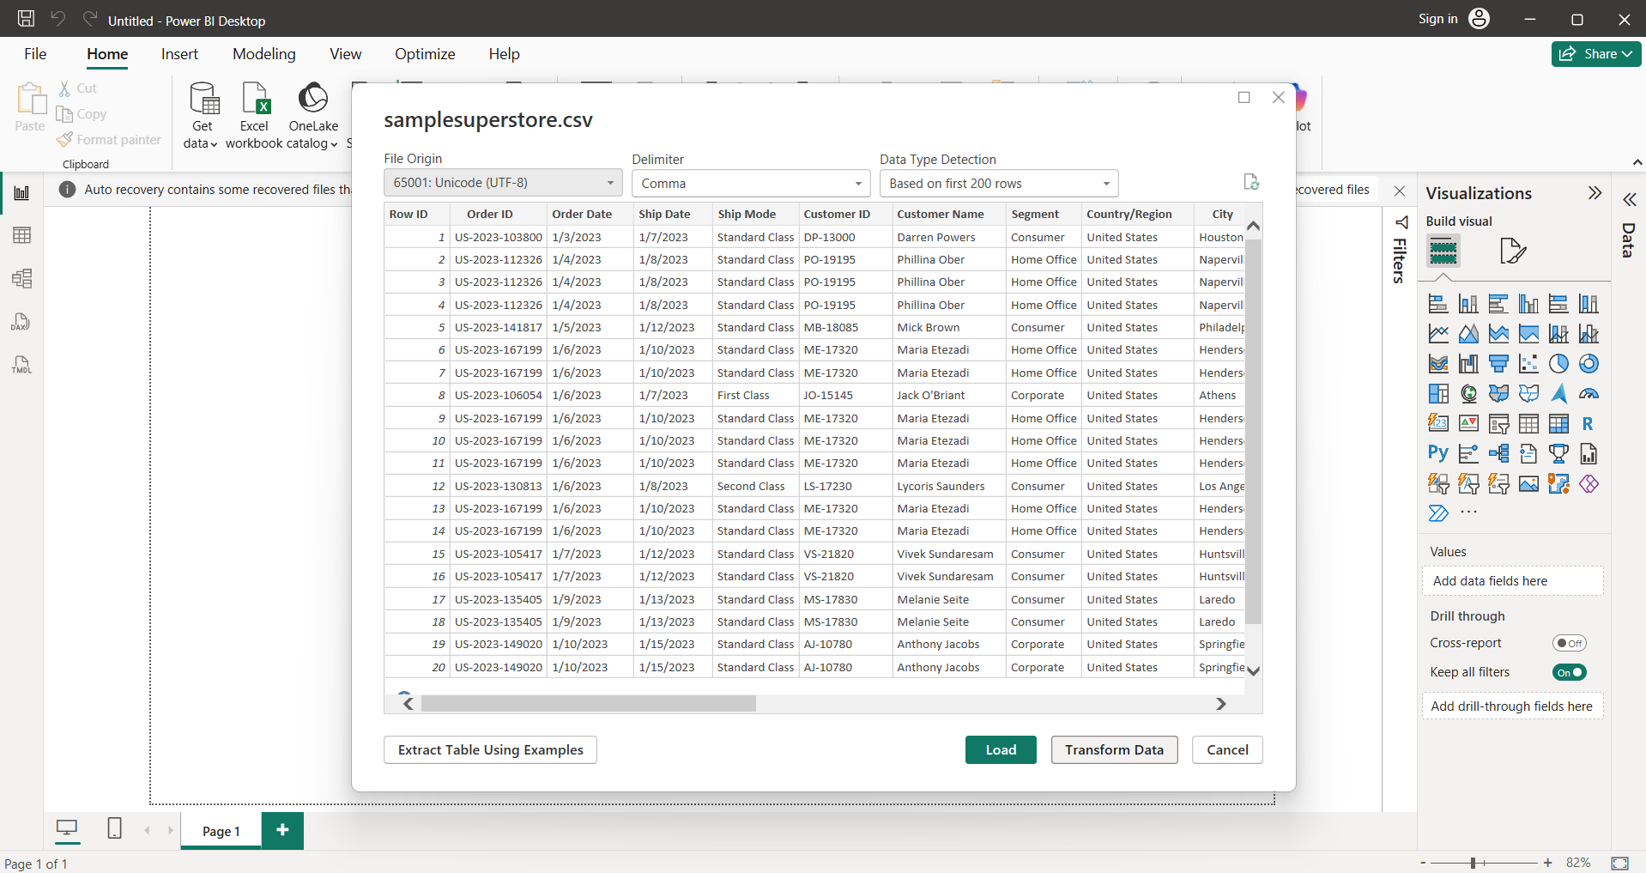
Preview of the Superstore Sales dataset before transformation

- The Transform Data option was selected to open Power Query Editor. Power Query was used to inspect the dataset and perform the required data-cleaning and transformation operations.
The dataset was inspected in Power Query Editor to understand its structure, columns, data types, and data quality. The dataset contains 10,194 records and 21 columns.
The column quality indicators in Power Query were used to check for valid values, errors, and empty values. The dataset was checked for missing values and data errors before performing transformations.

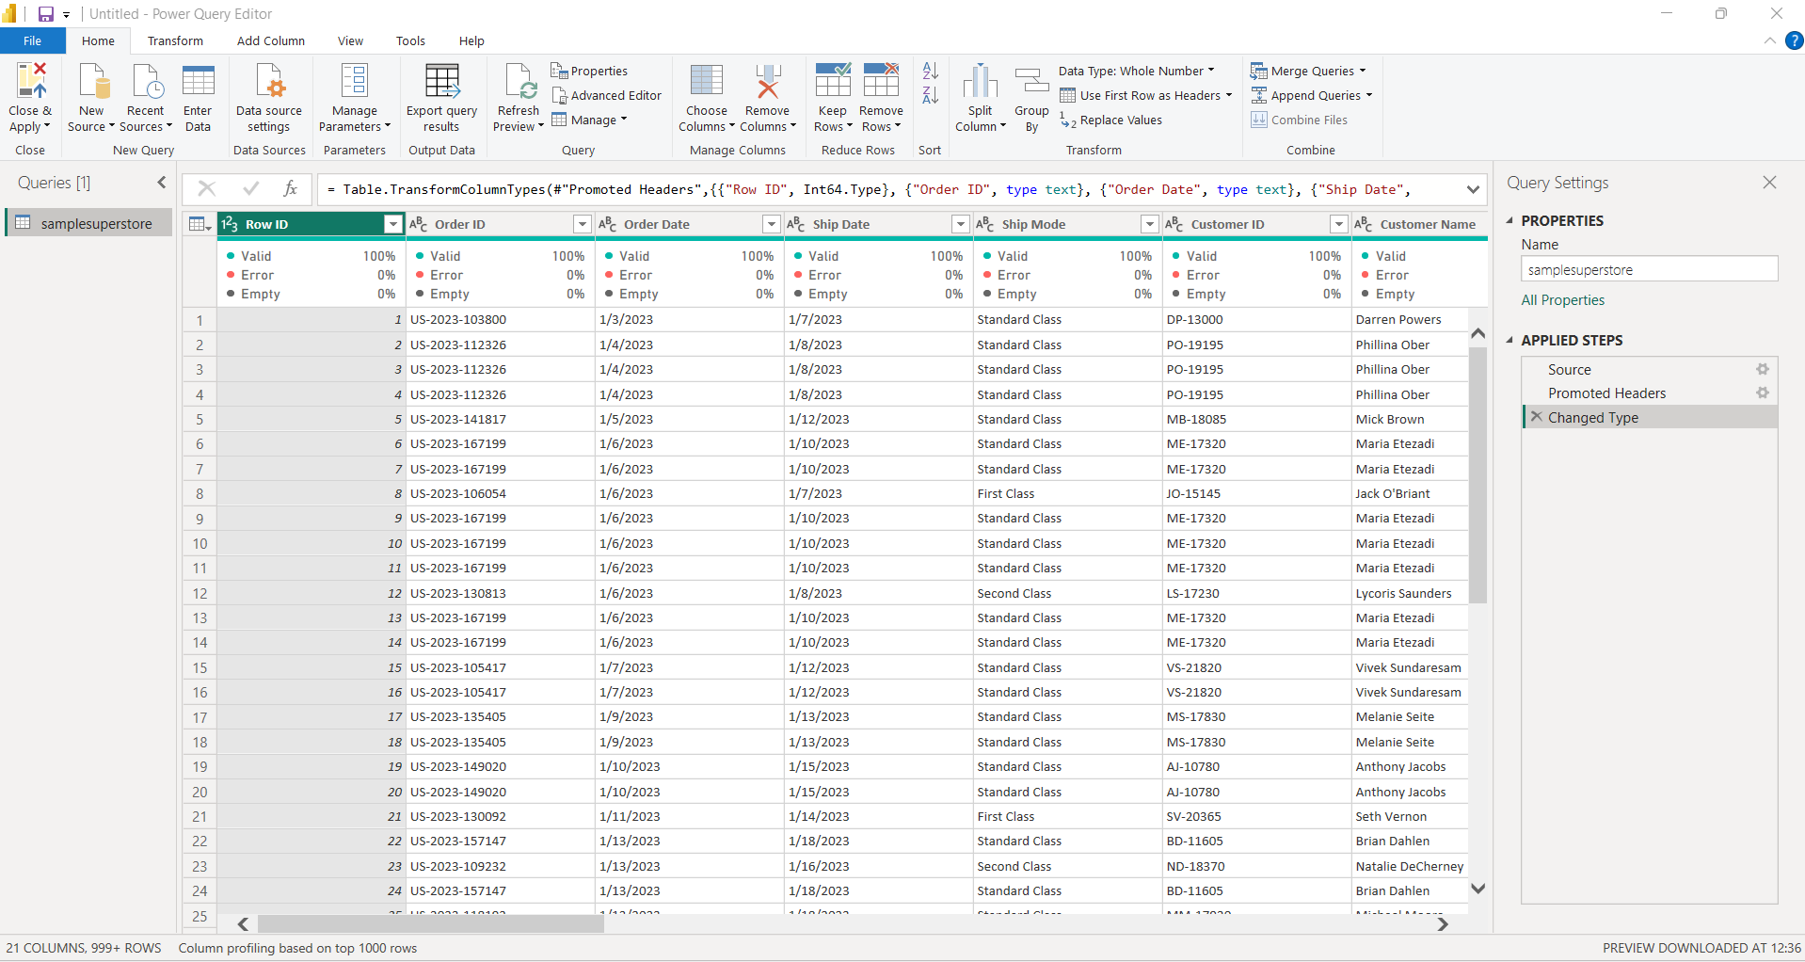
Superstore Sales dataset opened in Power Query Editor

- The Order Date and Ship Date columns were converted to the Date data type using the appropriate English (United States) locale to correctly interpret the date values in the CSV dataset.
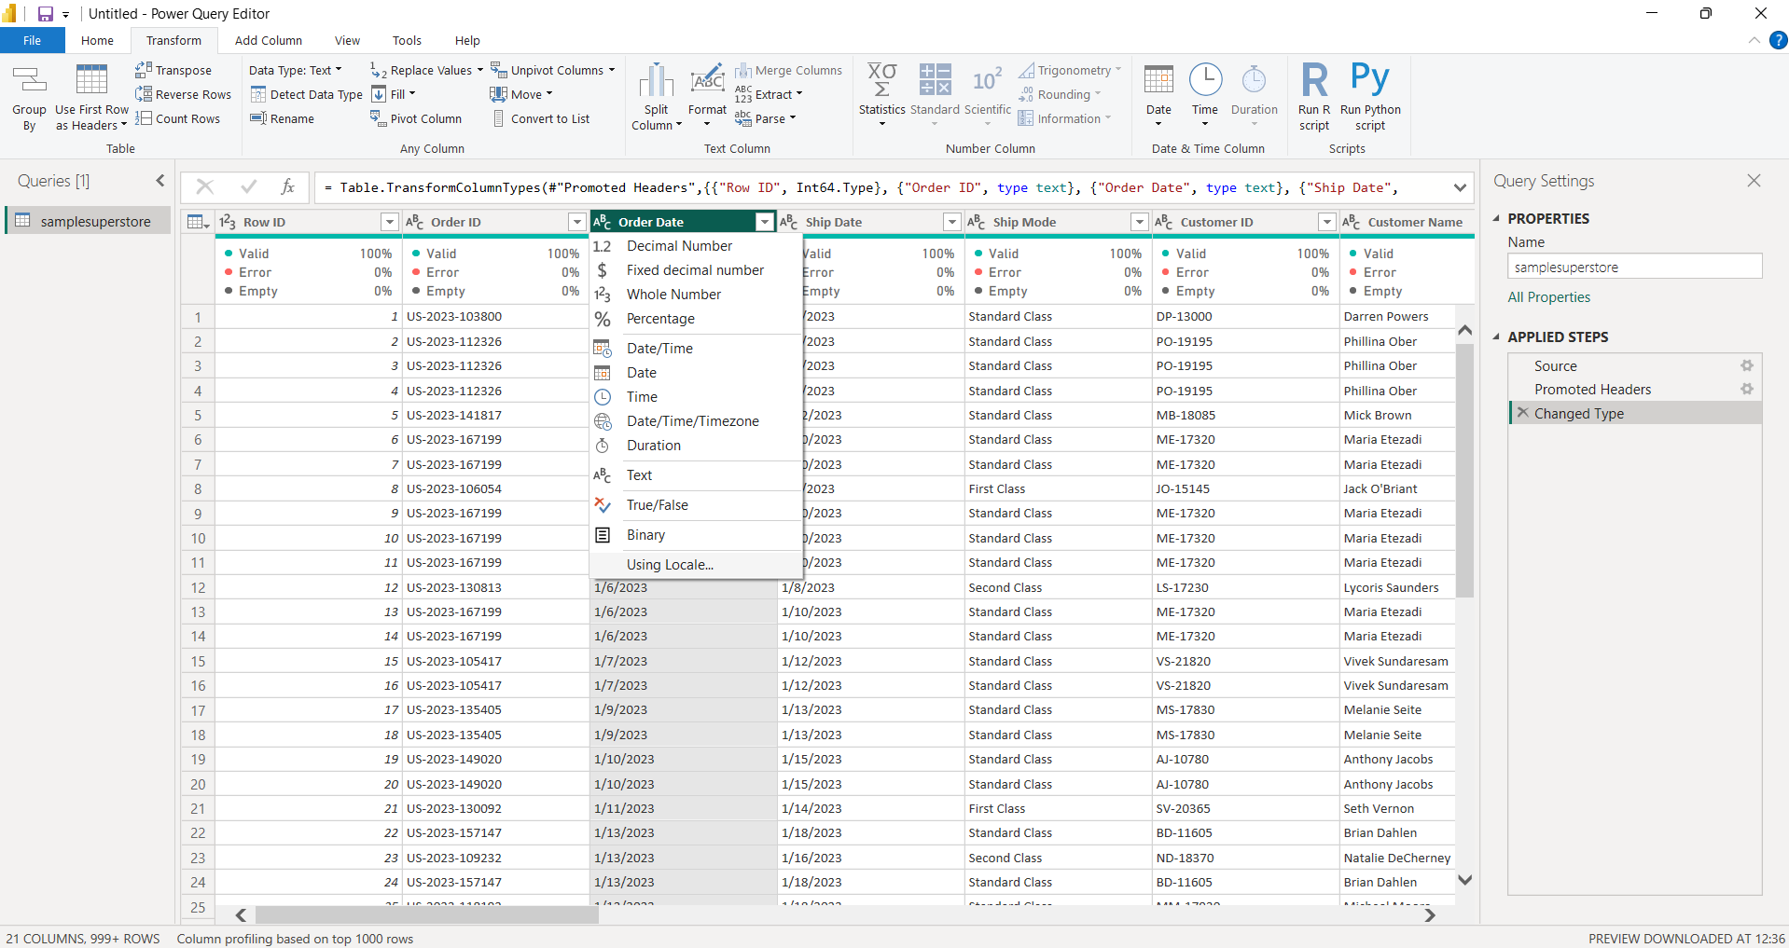

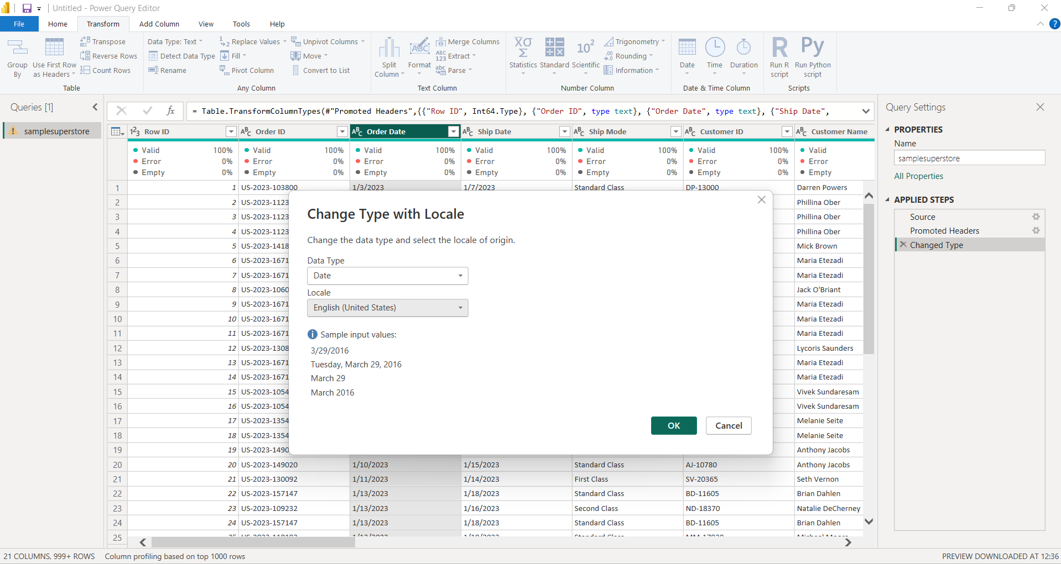

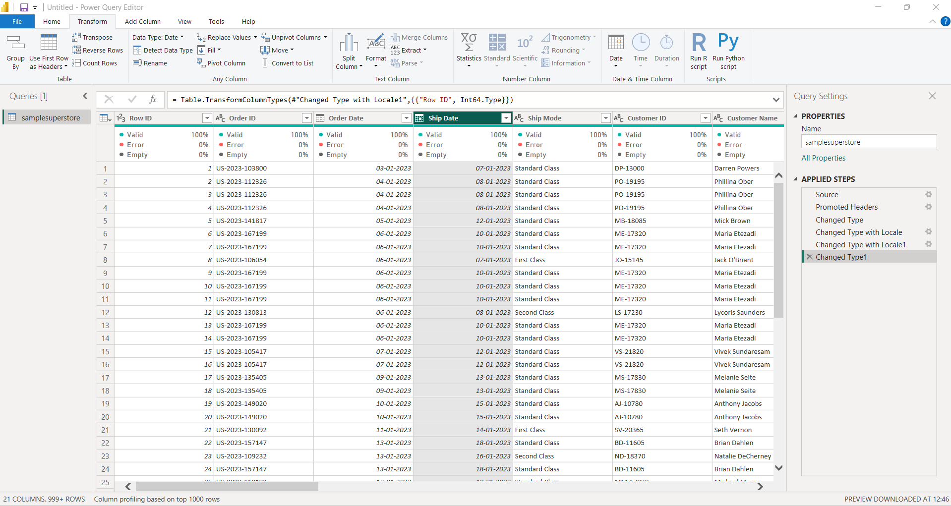
Order Date and Ship Date converted to Date format using the appropriate locale

- Appropriate data types were assigned to the dataset columns. Date fields were converted to Date, numerical fields such as Sales and Profit were converted to Decimal Number, Quantity was converted to Whole Number, and identifier fields such as Customer ID and Product ID were maintained as Text.
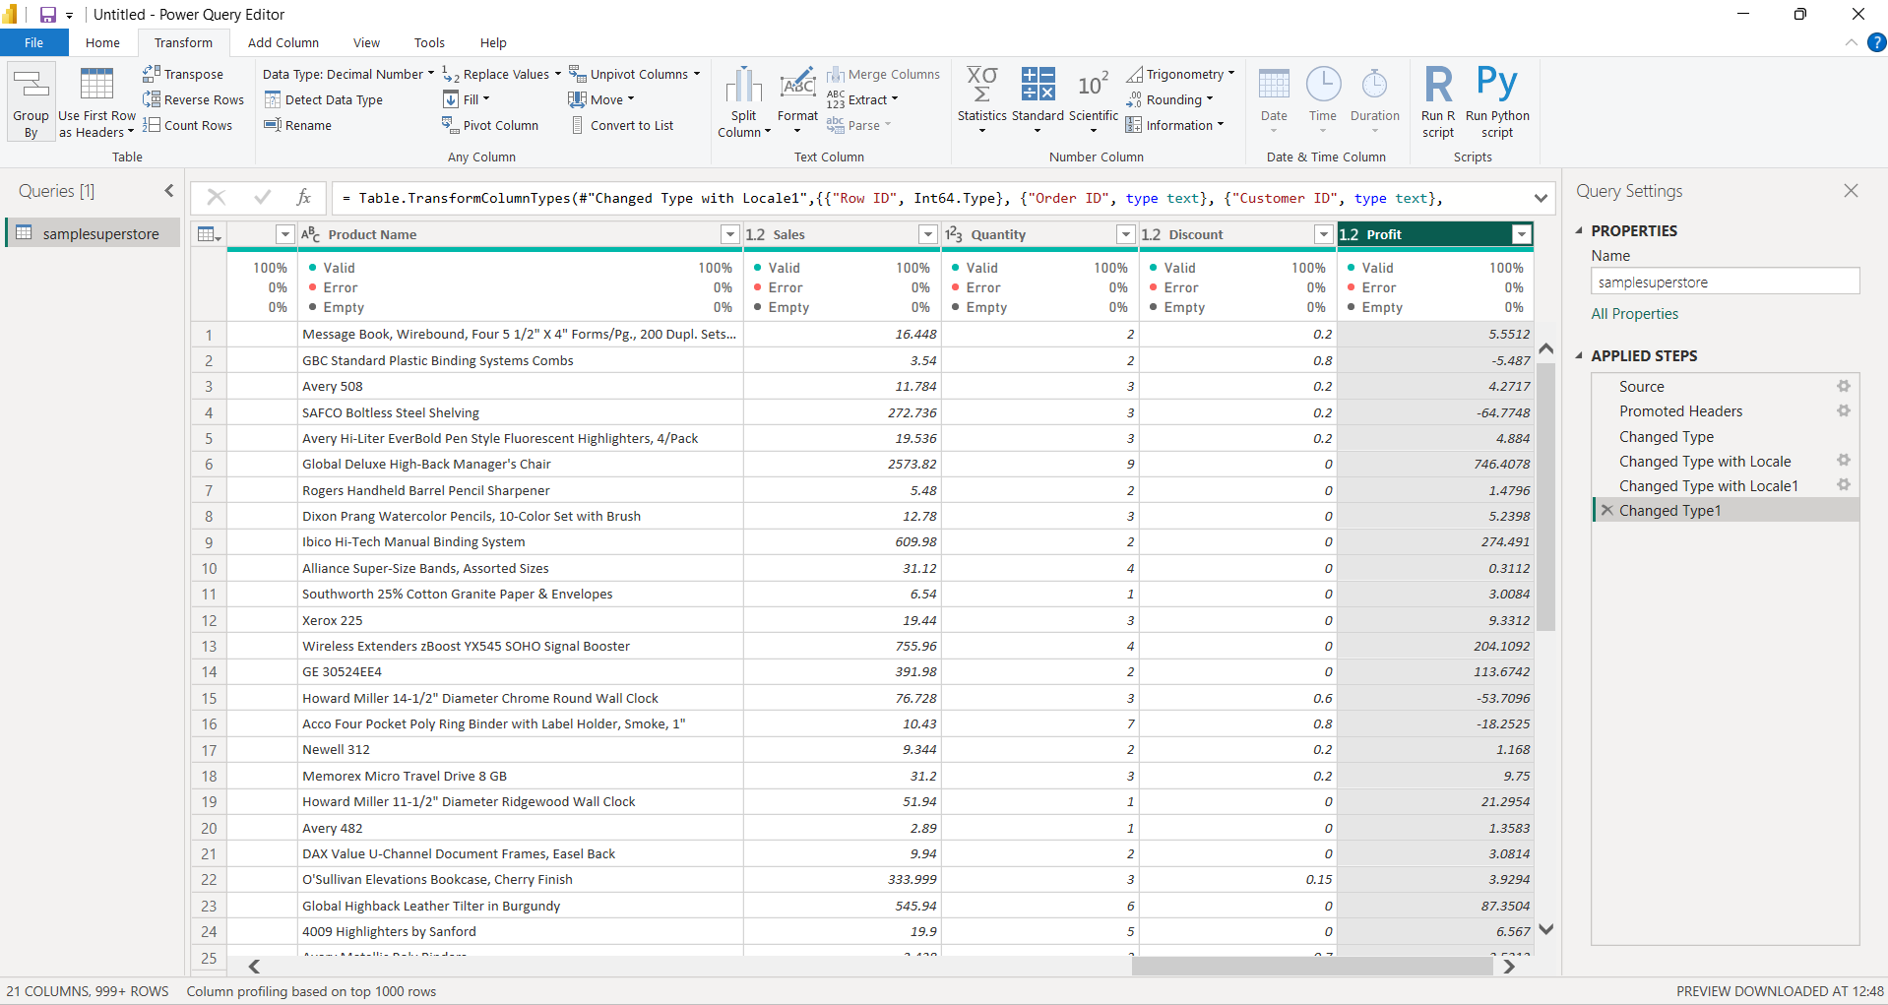
Appropriate data types assigned to the Superstore dataset columns

- Text-based categorical fields were standardized using the Trim and Clean transformations in Power Query. Columns such as Category, Sub-Category, Segment, Region, and other text fields were cleaned to remove unnecessary spaces and non-printing characters.
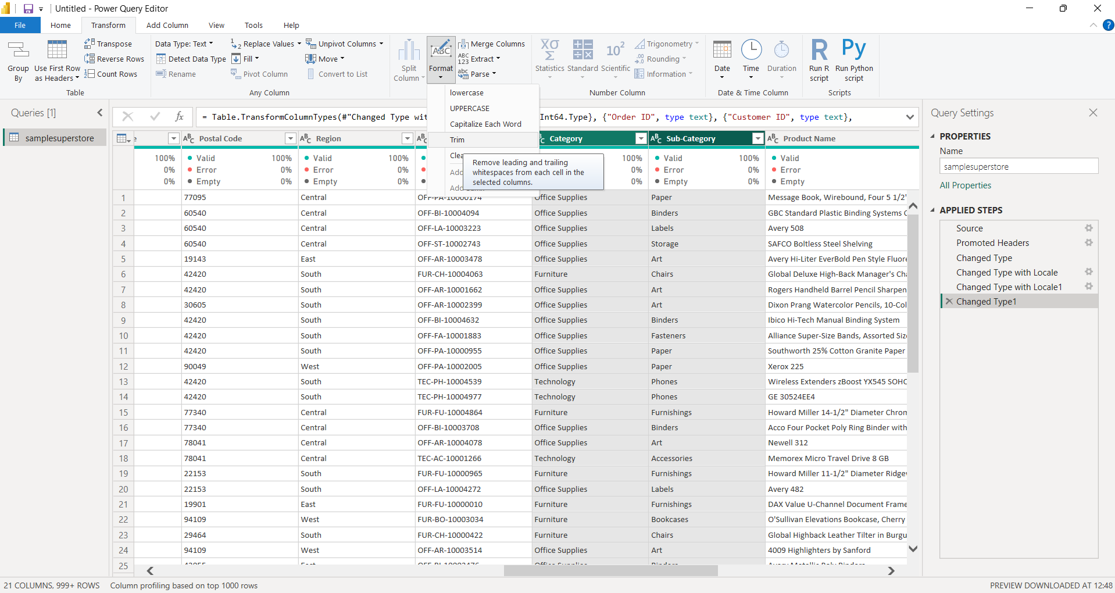

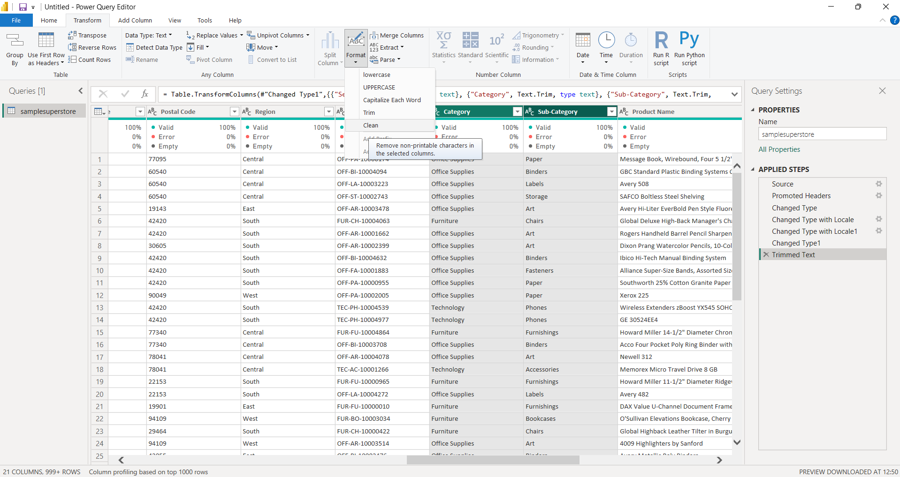
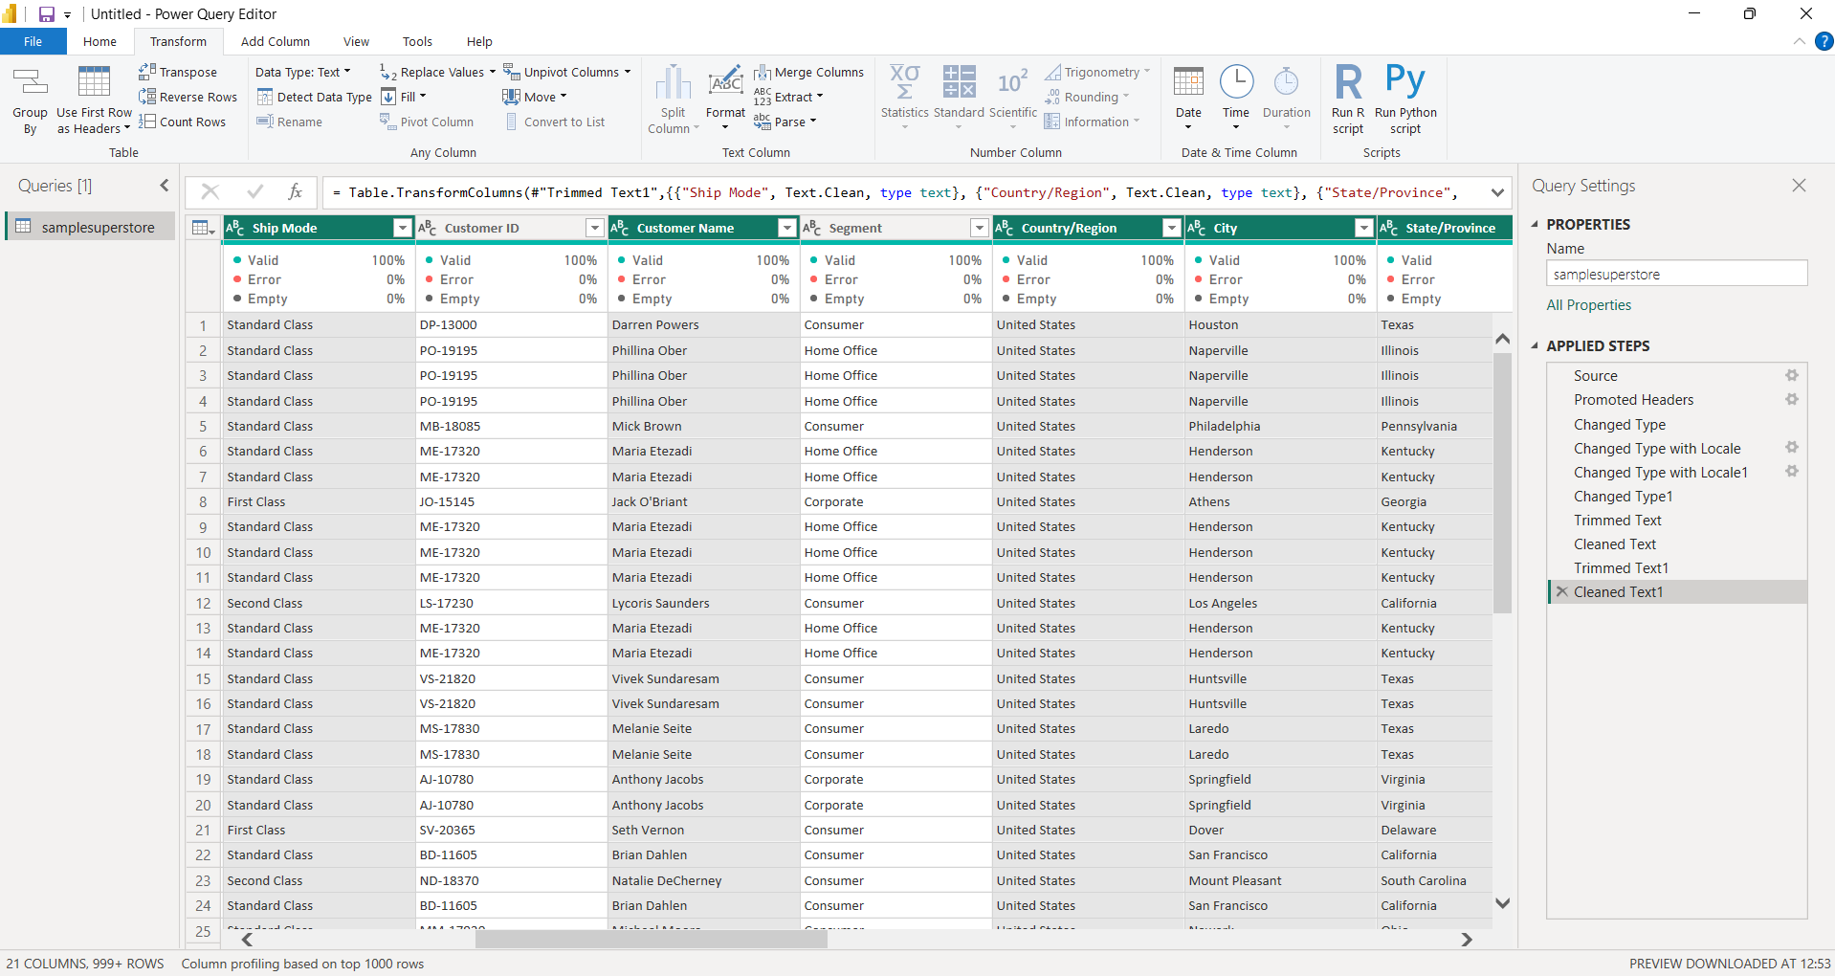
Text fields standardized using Trim and Clean transformations

- A new Order Year column was created from the Order Date column using the Date transformation options in Power Query.
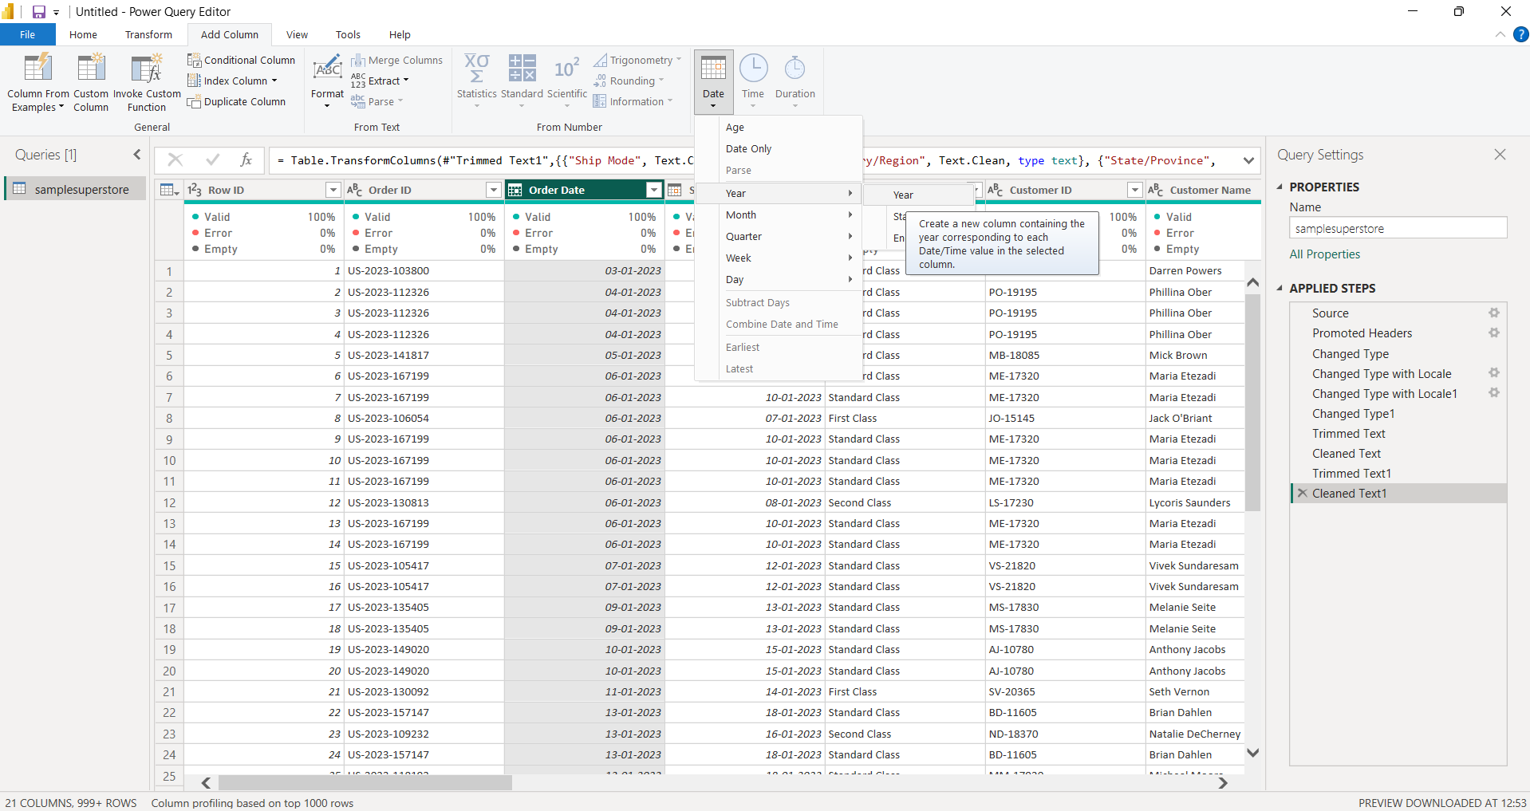
Order Year extracted from the Order Date column.

- Column is renamed as Order Year.
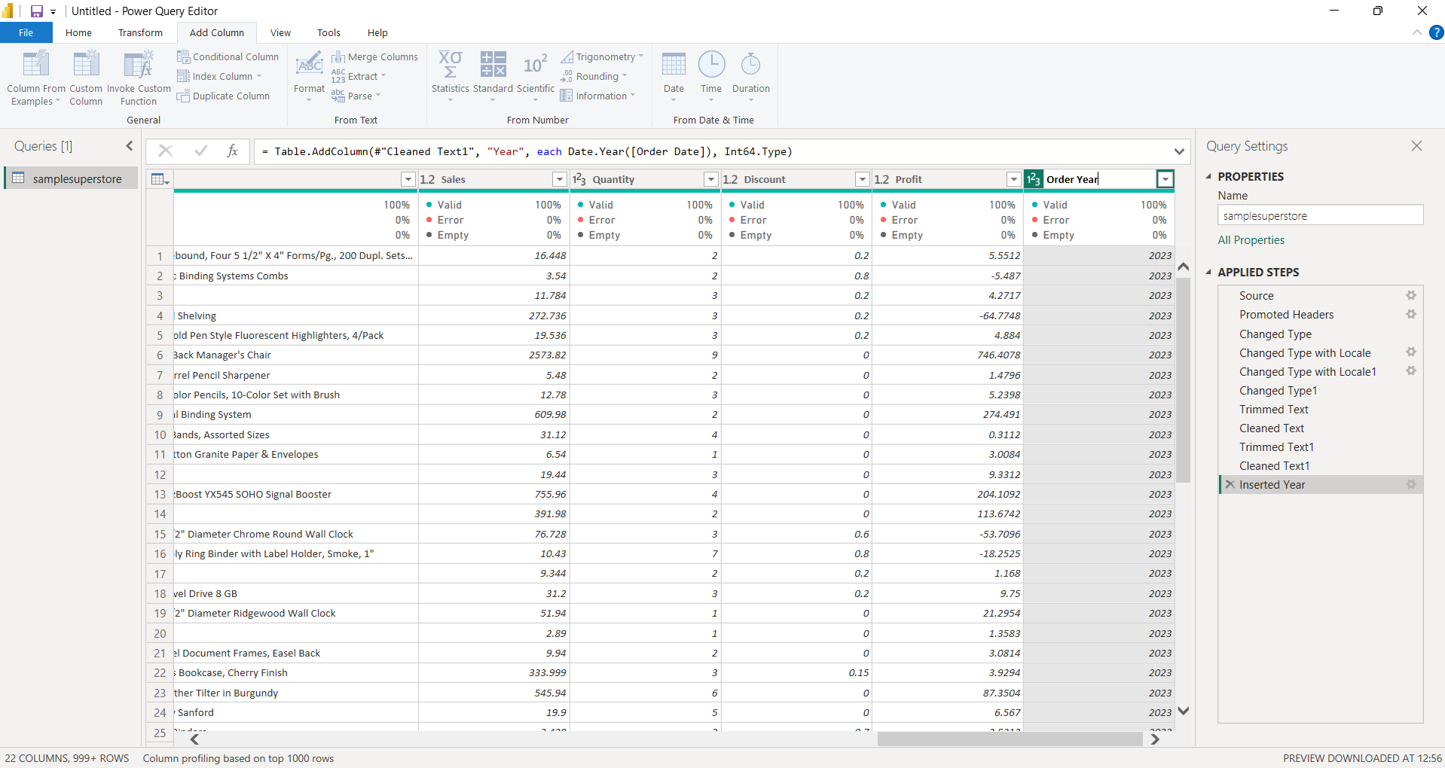

- Quarter information was extracted from Order Date. Both a numerical quarter value and a formatted quarter value such as Q1, Q2, Q3, and Q4 were created for future analysis. They are renamed as Order Quarter Number and Order Quarter.
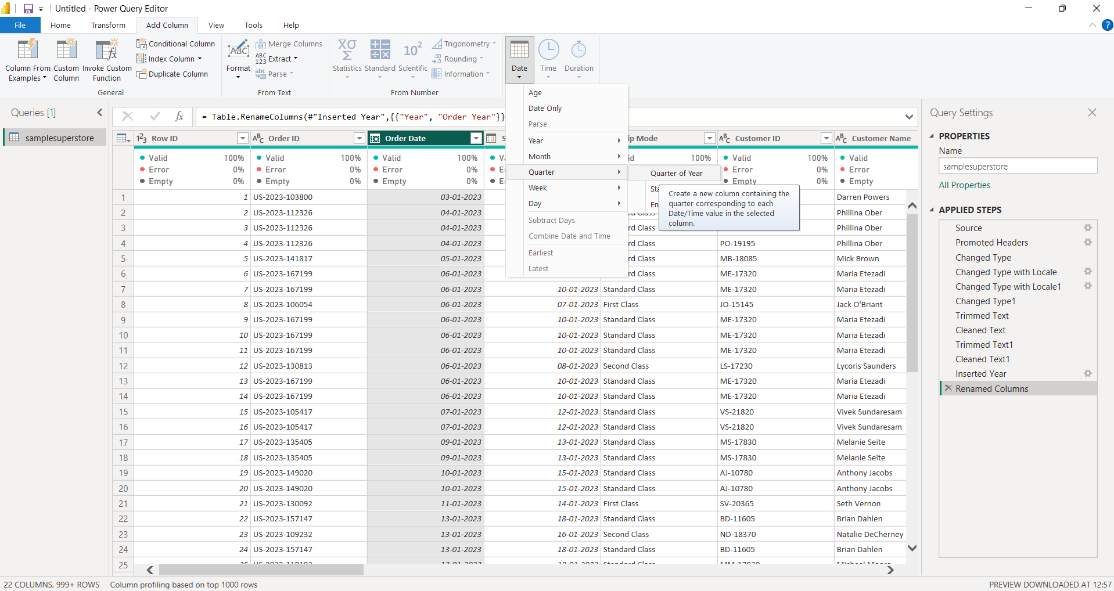
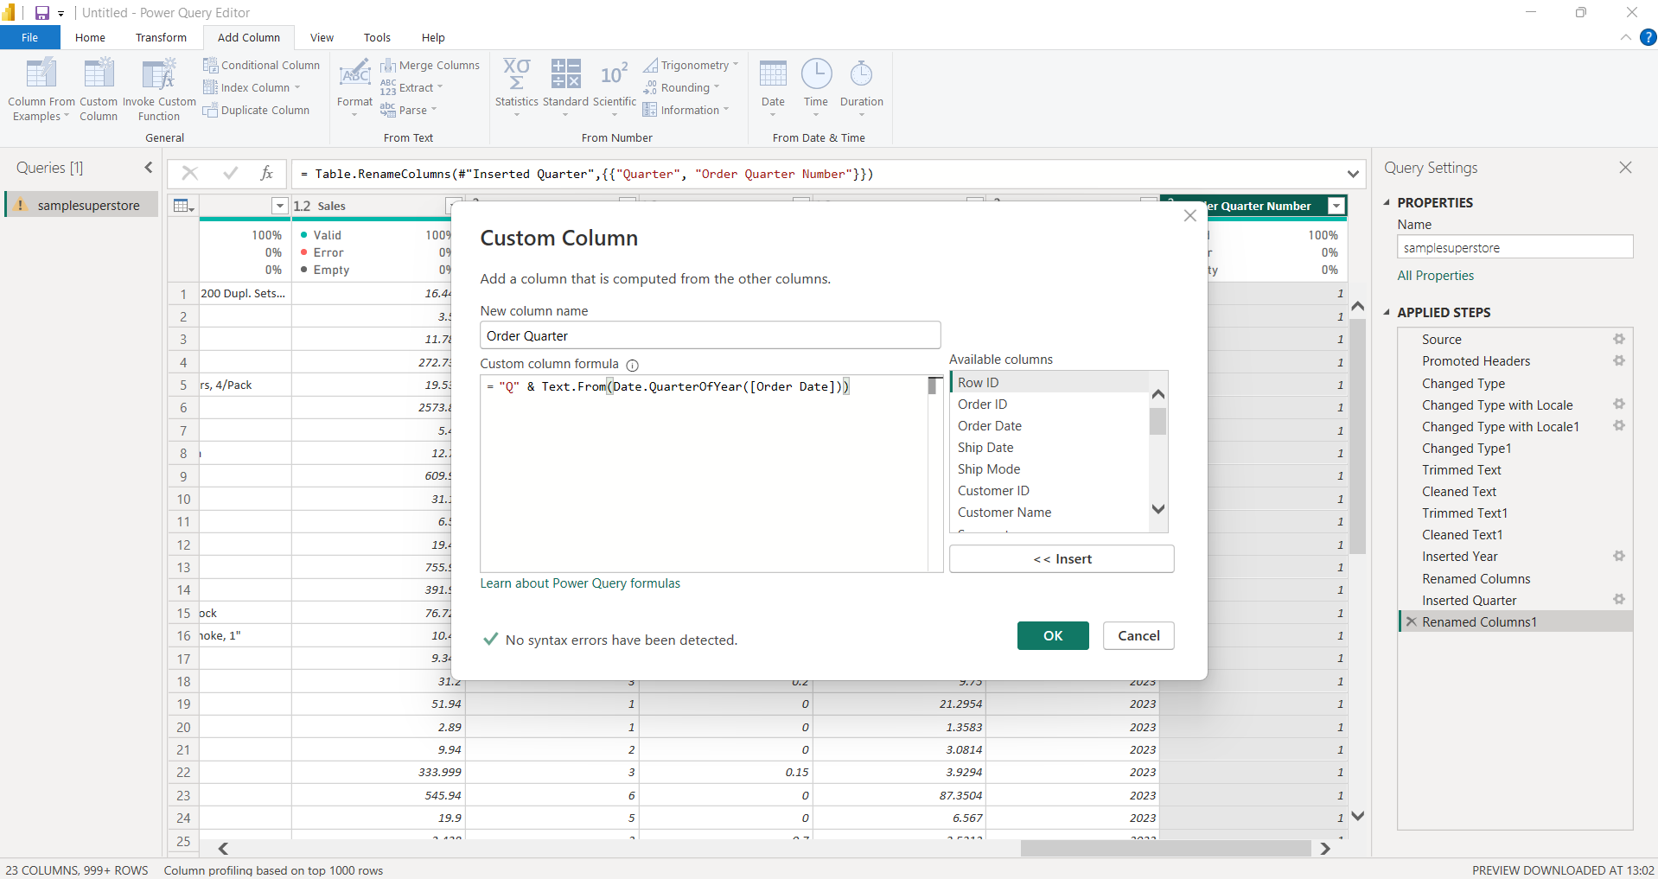

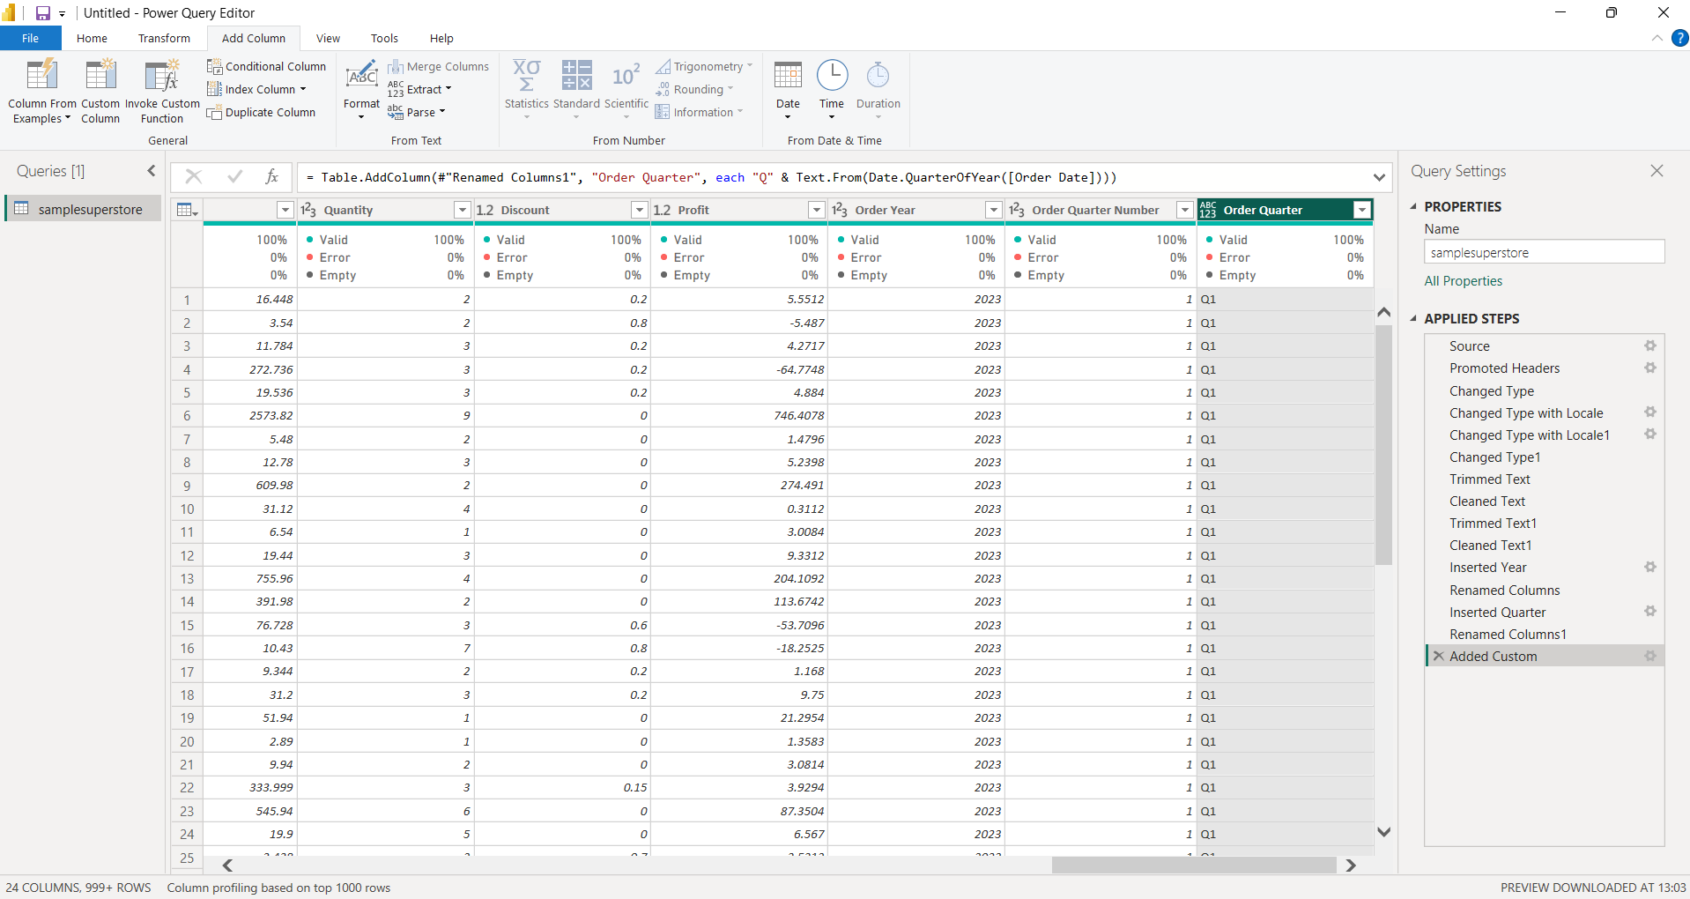
Quarter attributes created from Order Date

- Month attributes were extracted from Order Date. A Month Number and Month Name column were created to support chronological analysis and visualization.
- Day-level attributes were extracted from Order Date. The Day and Day of Week columns were created to enable analysis based on individual days and weekdays.
- The final transformed dataset contains the required temporal attributes: Order Year, Order Quarter, Order Month Number, Order Month, Order Day, and Order Day of Week.

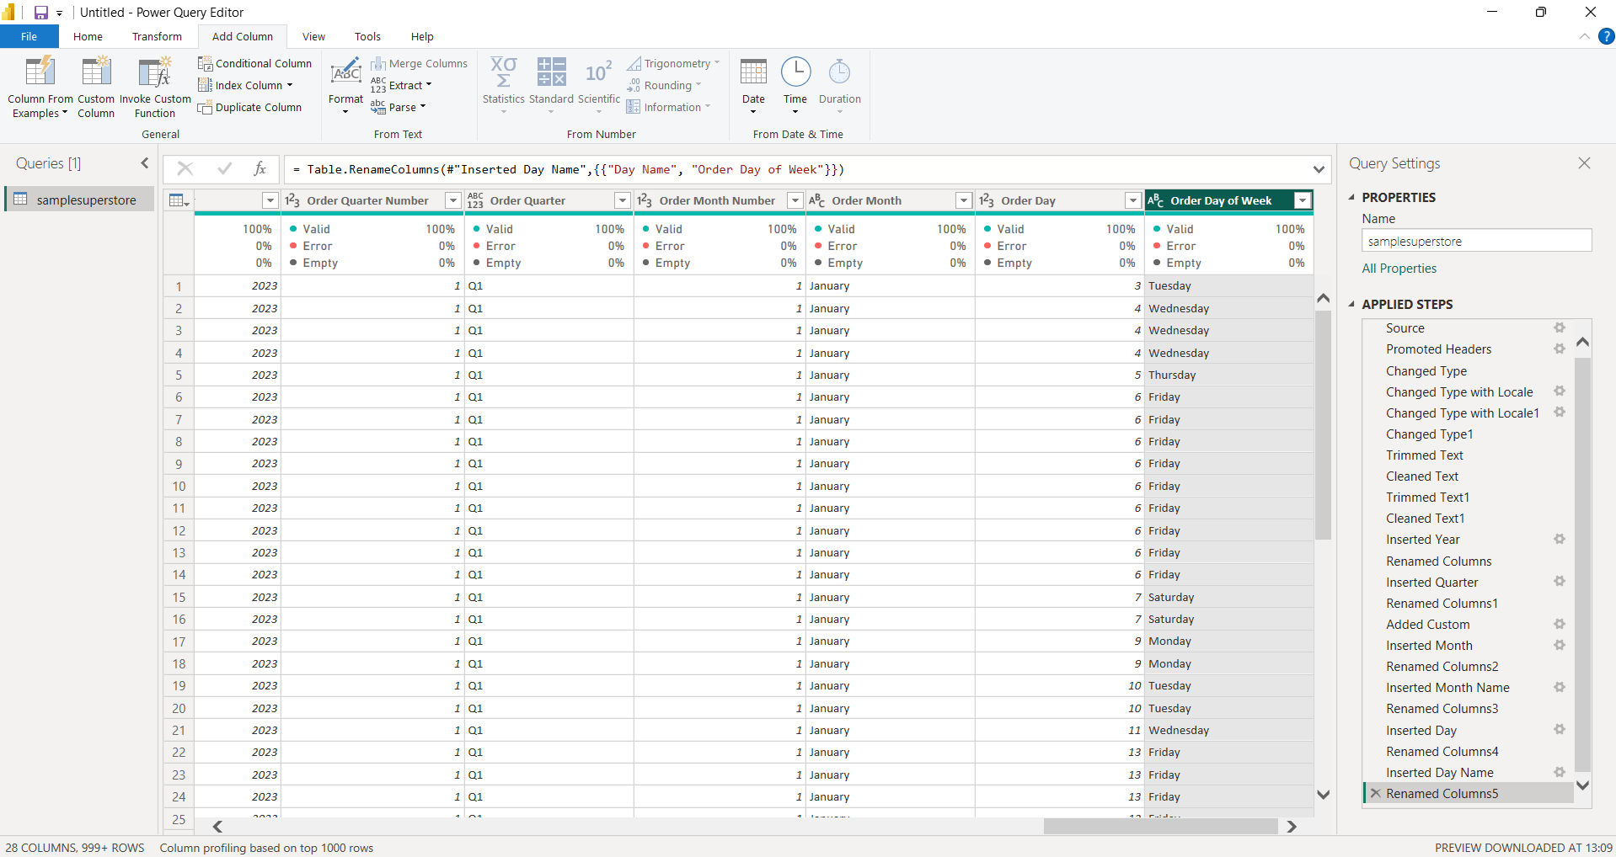
Final temporal attributes extracted from the Order Date field

- The Applied Steps panel was reviewed to verify the sequence of transformations performed on the dataset. The steps record the data type changes, text cleaning, renaming, and date attribute creation performed during the data preparation process.
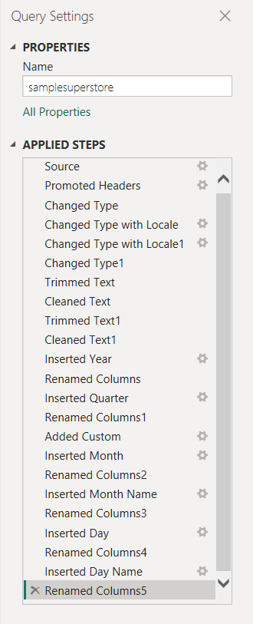
Applied Steps showing the sequence of data transformations performed in Power Query

- After completing the transformations, the final dataset was reviewed to verify that the required columns were available and that the transformed values were correctly displayed.
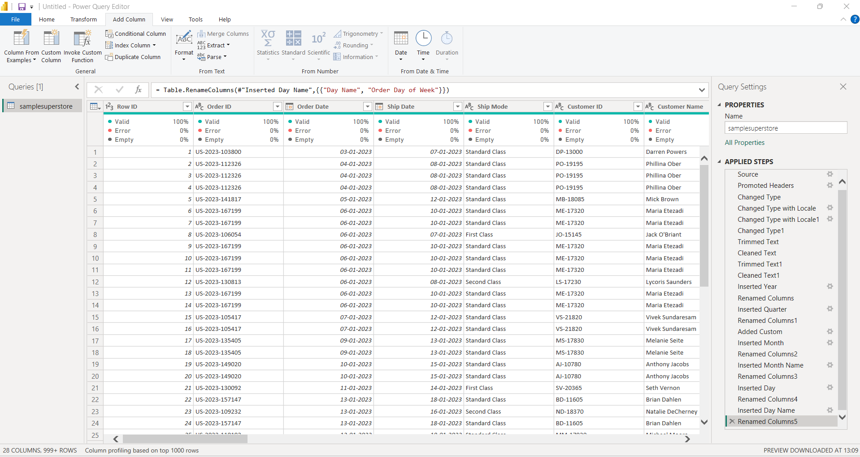
Final cleaned and transformed Superstore dataset in Power Query

- After completing the required transformations, Close & Apply was selected to load the cleaned dataset into the Power BI data model.
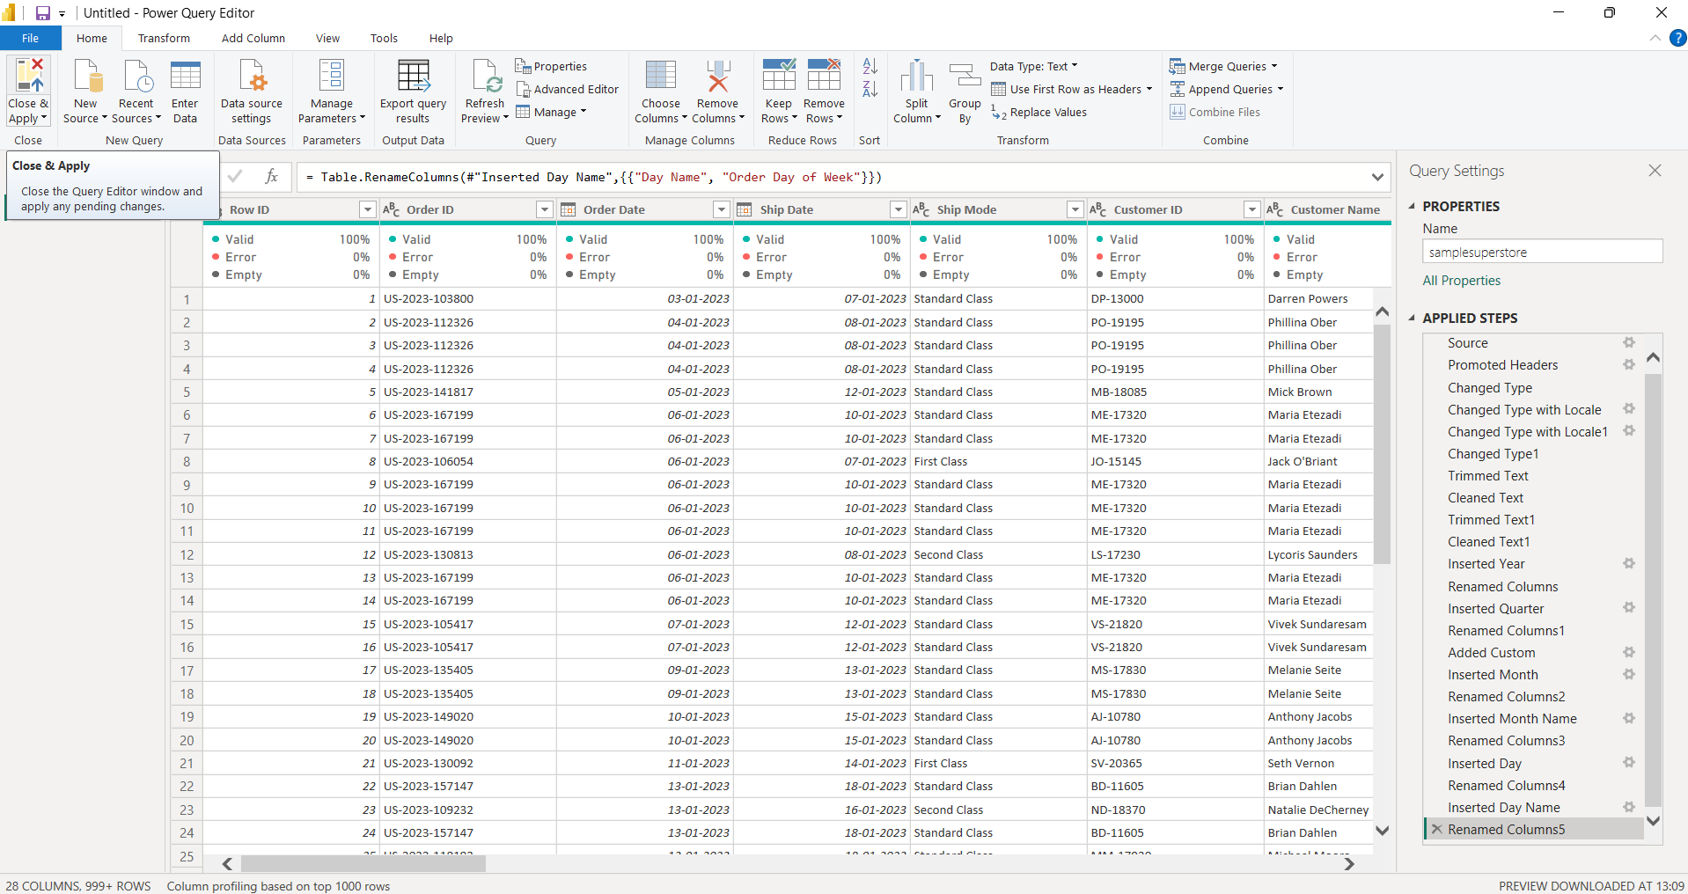
Closing Power Query and applying the transformations to the Power BI data model

- The Report View was opened after applying the transformations. This view is used to create visualizations and build the business intelligence dashboard.
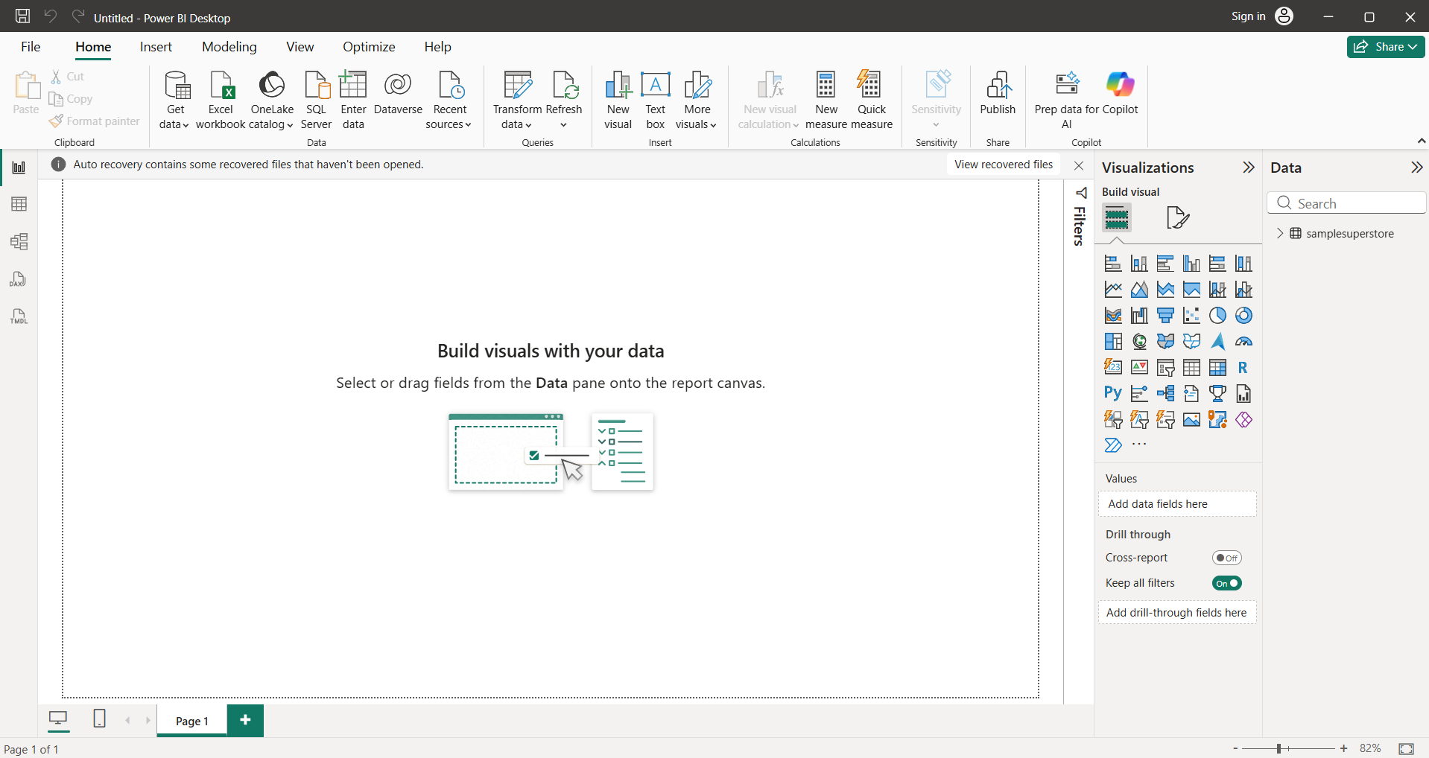
Power BI Report View after loading the transformed dataset

- The Data View was used to verify that the cleaned and transformed data had been successfully loaded into Power BI.
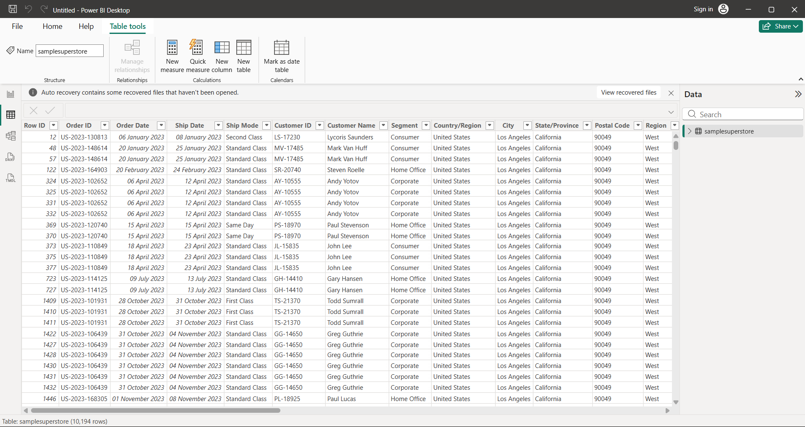
Data View displaying the loaded Superstore dataset

- The Model View was inspected to verify the structure of the data model.
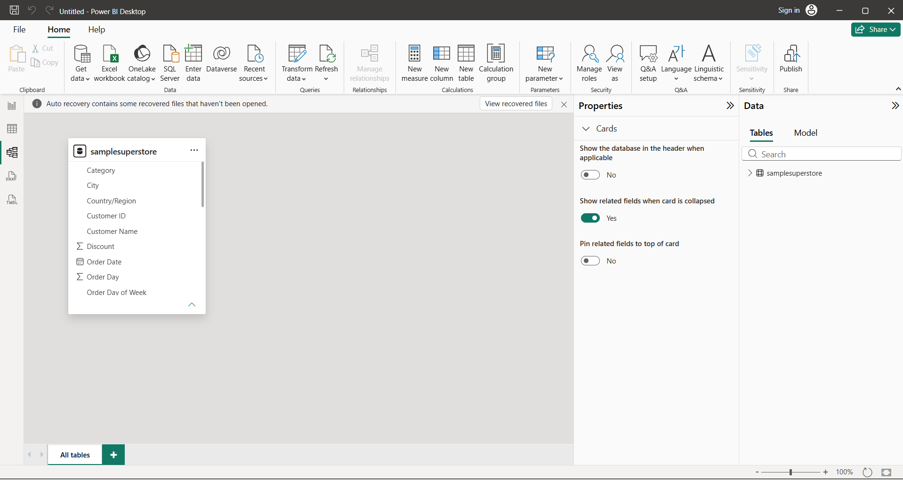
Model View showing the Superstore dataset in the Power BI data model

- The Order Month column was configured to sort according to Order Month Number so that the months appear chronologically rather than alphabetically. Similarly, Order Quarter was sorted using the Quarter Number column.
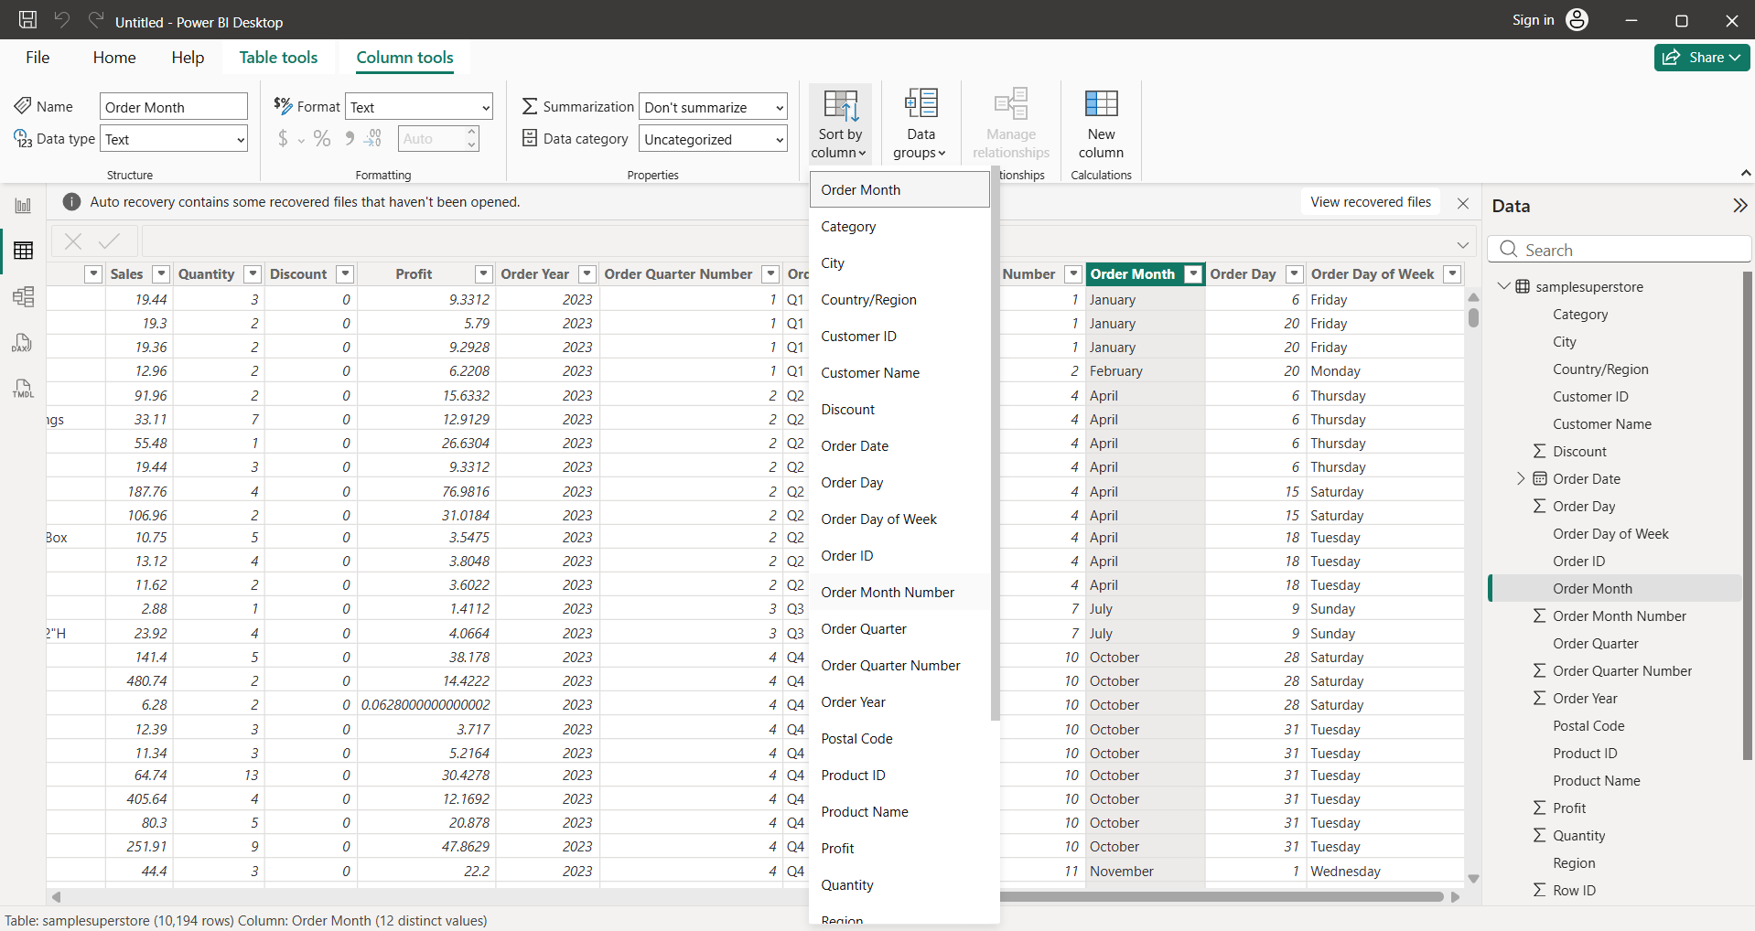
Order Month configured for chronological sorting using Order Month Number
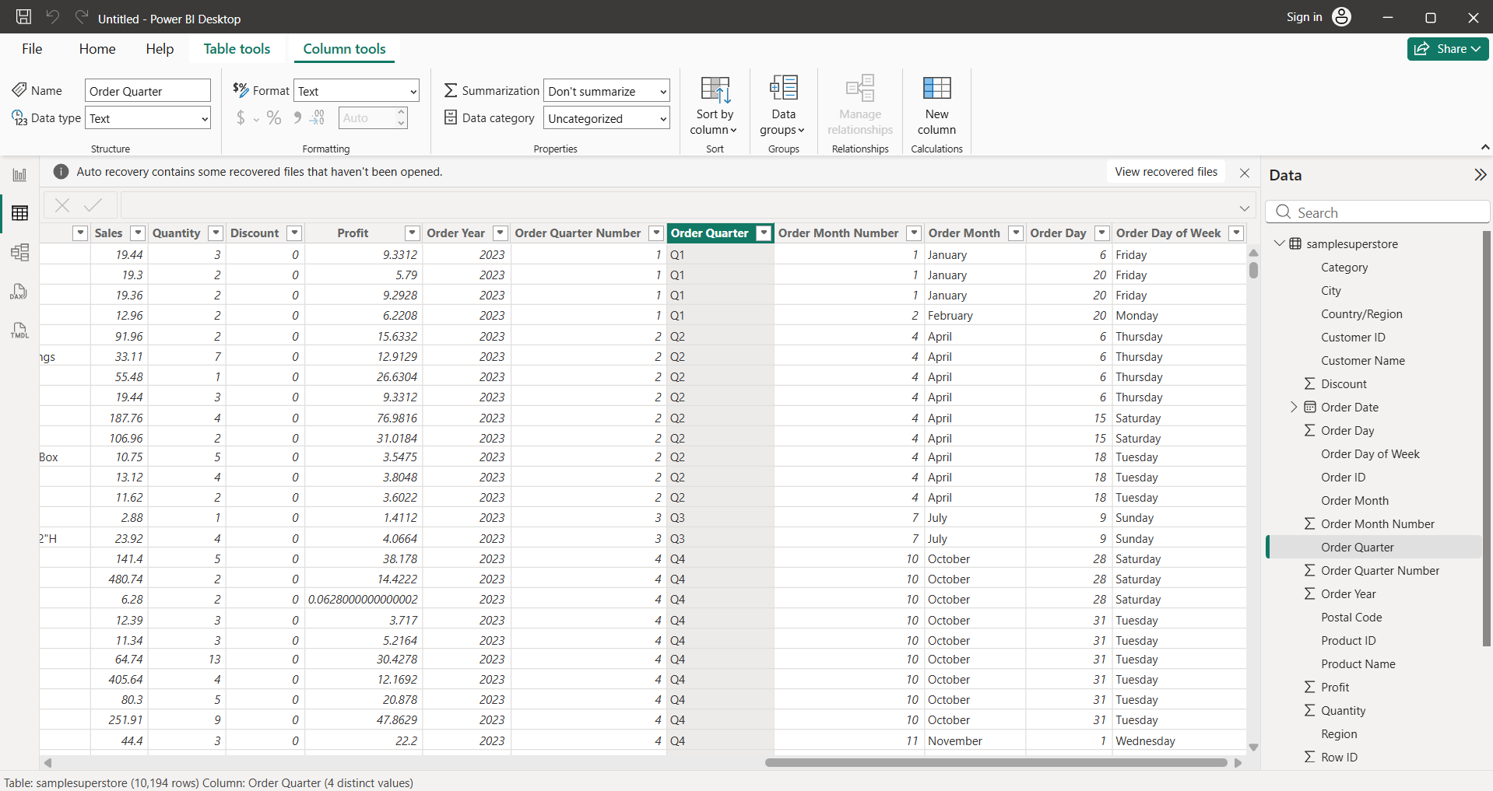
Order Quarter configured for chronological sorting using Quarter Number Column

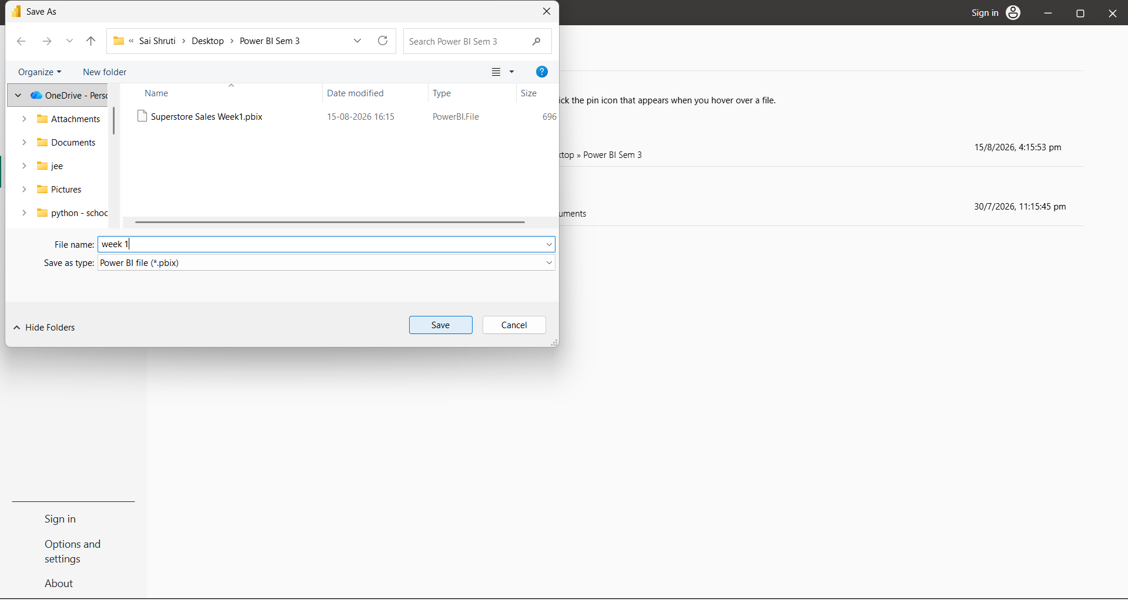
The file is successfully saved

CONCLUSION
The Superstore Sales dataset was successfully imported into Power BI and prepared using Power Query Editor. The dataset was inspected for data quality, appropriate data types were assigned, text fields were cleaned and standardized, and date attributes were extracted from the Order Date field. The transformed dataset was then loaded into Power BI using Close & Apply and verified using Report, Data, and Model views. The cleaned data is now ready for further analysis and dashboard development.

